Latin America Physical Map Labeling List
Directions: Label the following items on the map using pages S29-S32.

Bodies of Water
Amazon River Gulf of Mexico Caribbean Sea

Lake Maracaibo Panama Canal Strait of Magellan

Gulf of California Angel Falls

Landforms
Andes Mountain Yucatan Peninsula Falkland Islands Baja California

Sierra Madre Occidental Amazon Basin Brazilian Highlands

Imaginary Lines
Draw and label: Equator Tropic of Capricorn Tropic of Cancer

Directions: Use the your map as well as the information found on pages 210-211 to answer the following questions.
- Which mountain range is the tallest in all of Latin America?

- The island of Hispaniola is made of which countries?

- What two major lakes are located in Bolivia?

- Which man-made river connects the Atlantic and Pacific Oceans through Central America?

- List all of the countries that have the Andes Mountains in them.

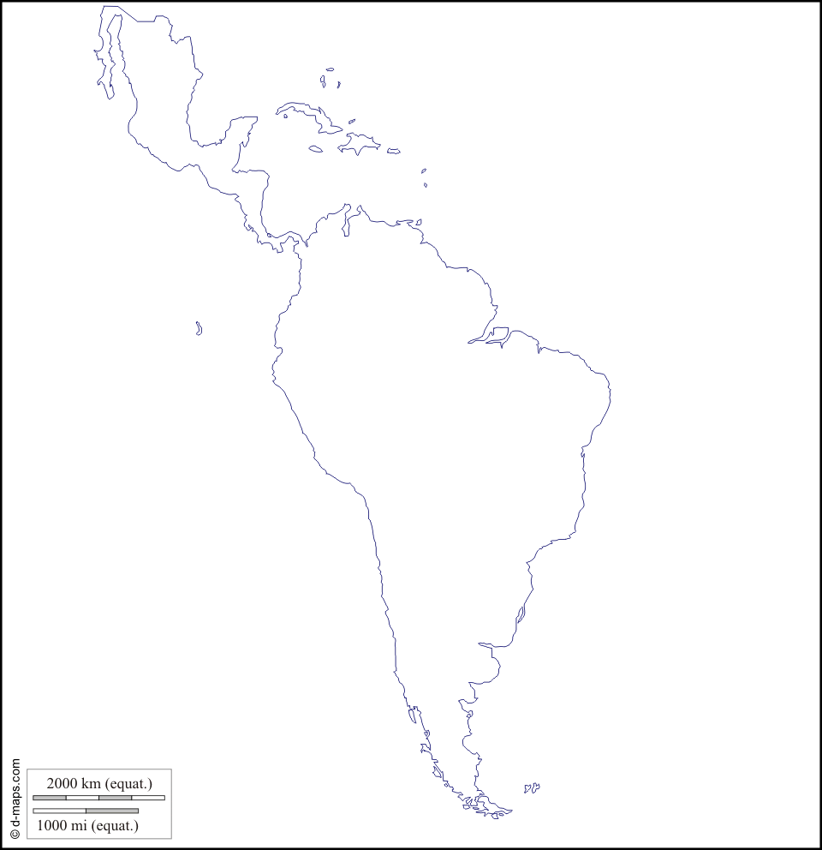
- List all of the countries that have the Andes Mountains on their land.

