Political Map of Africa Labeling List
Label the following items on the map use page s37-s38 and 472-473
Countries
Morocco | Algeria | Libya
Egypt | Tunisia | Mauritania
Mali | Niger | Chad
Sudan | Eritrea | Ethiopia
Djibouti | Somalia | Central African Republic
Cameroon | Nigeria | Senegal
Liberia | Gabon | Dem. Rep. of Congo
Uganda | Kenya | Tanzania
Angola | Namibia | Zimbabwe
Mozambique | Madagascar | South Africa
Zambia | Botswana | Ghana

Cities
Khartoum | Kinshasa
Cape Town | Nairobi
Abuja | Monrovia
Harare | Kampala
Luanda | Addis Ababa
Mogadishu | Bangui

Answer the following questions in the space provided below.
- What African capital city is the furthest south?

- Which direction would you be traveling if you went from Addis Ababa to Nairobi?

- Which African nations likely depend on the Red Sea for economic activity and travel?

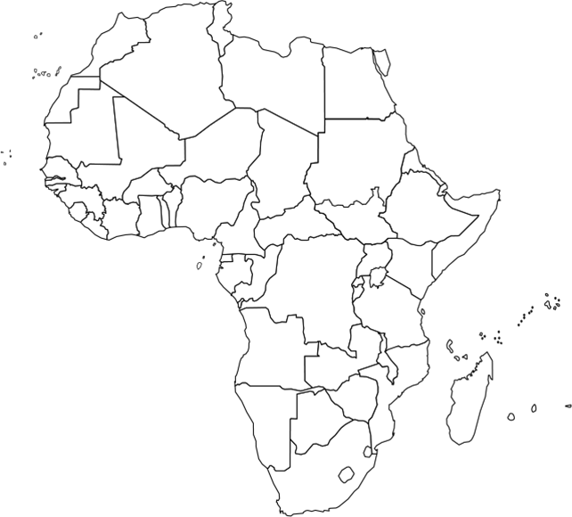
Political Map

