Physical Map of Africa Labeling List
Label the following items on the map use page s37-s38 and 472-473
Bodies of Water
Atlantic Ocean | Indian Ocean
Mediterranean Sea | Zambezi River
Lake Victoria | Lake Chad
Congo River | Nile River
Orange River | Niger River
Limpopo River

Landforms
Cape of Good Hope | Sahara Desert
Ethiopian Highlands | Mount Kilimanjaro
Kalahari Desert | Horn of Africa

Answer the following questions in the space provided below.
- What is the tallest mountain in Africa?

- In order to get from Madagascar to the Red Sea, you would need to travel around what African landform?

- What is the largest body of water located INSIDE the African continent?

- Which river provides much-needed fresh drinking water in the western Sahara Desert?

- What landform represents the southern tip of the African continent?
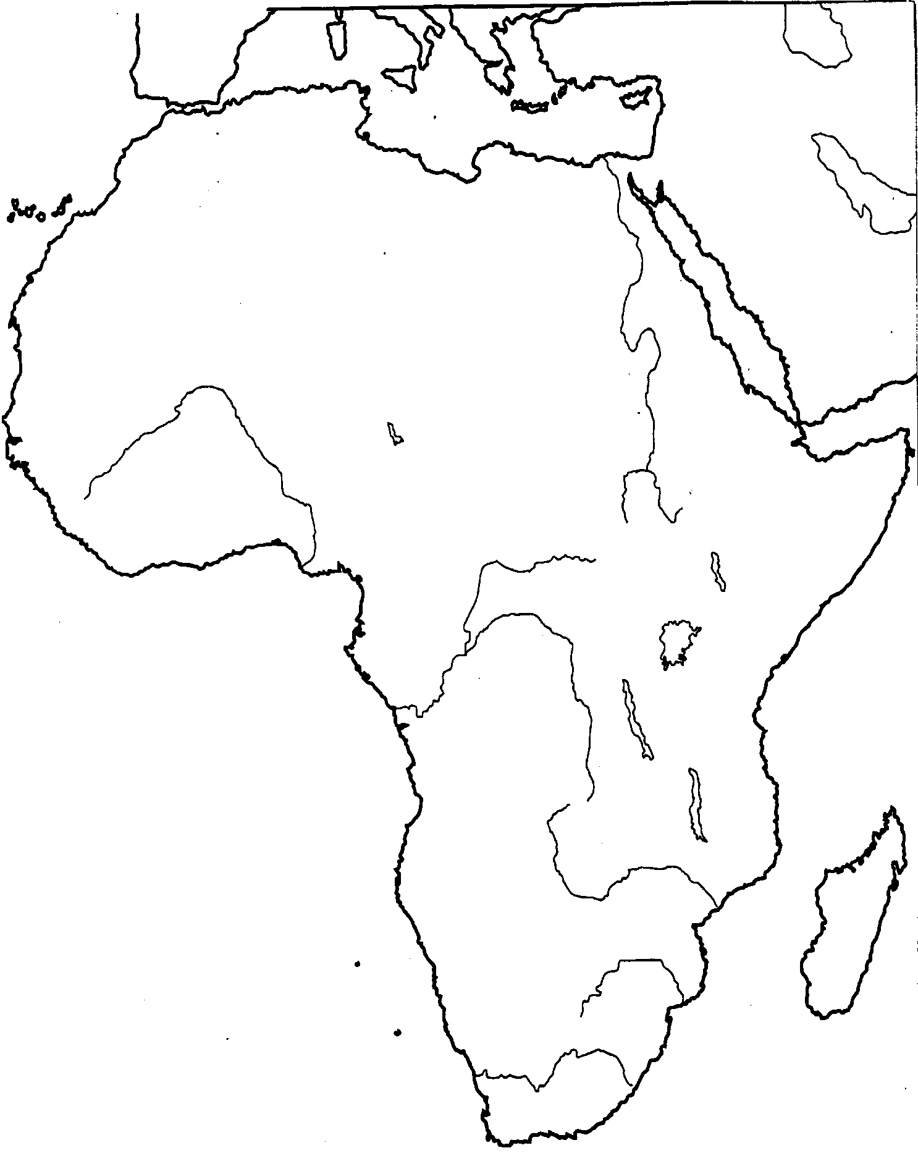
Physical Map

